Serverless Development 101

**HOS02A – Identity & Access Management (IAM)**

1/10/2019 Developed by Kevin Wang

1/10/2019 Checked by Clark Jason Ngo

1/10/2019 Tested by Tuan Khai and Minh Truong

2/4/2019 Revised by Sam Chung

4/9/2020 Reviewed by Apiwat Chuaphan

3/14/2021 Updated by Min Qiu

Center for Information Assurance (CIAE) @City University of Seattle (CityU)



An IAM user is required when a user try to operate services on AWS. An organization can give different employees different permissions based on their daily tasks through assigning different IAM users. We will create an IAM user and use it during our Serverless development course.

**Learning Outcomes**

* Add an Identity and Access Management (IAM) User

**Add an IAM User**

1. Visit <https://aws.amazon.com/>  
   Click the “Sign In to the Console” button to sign in.

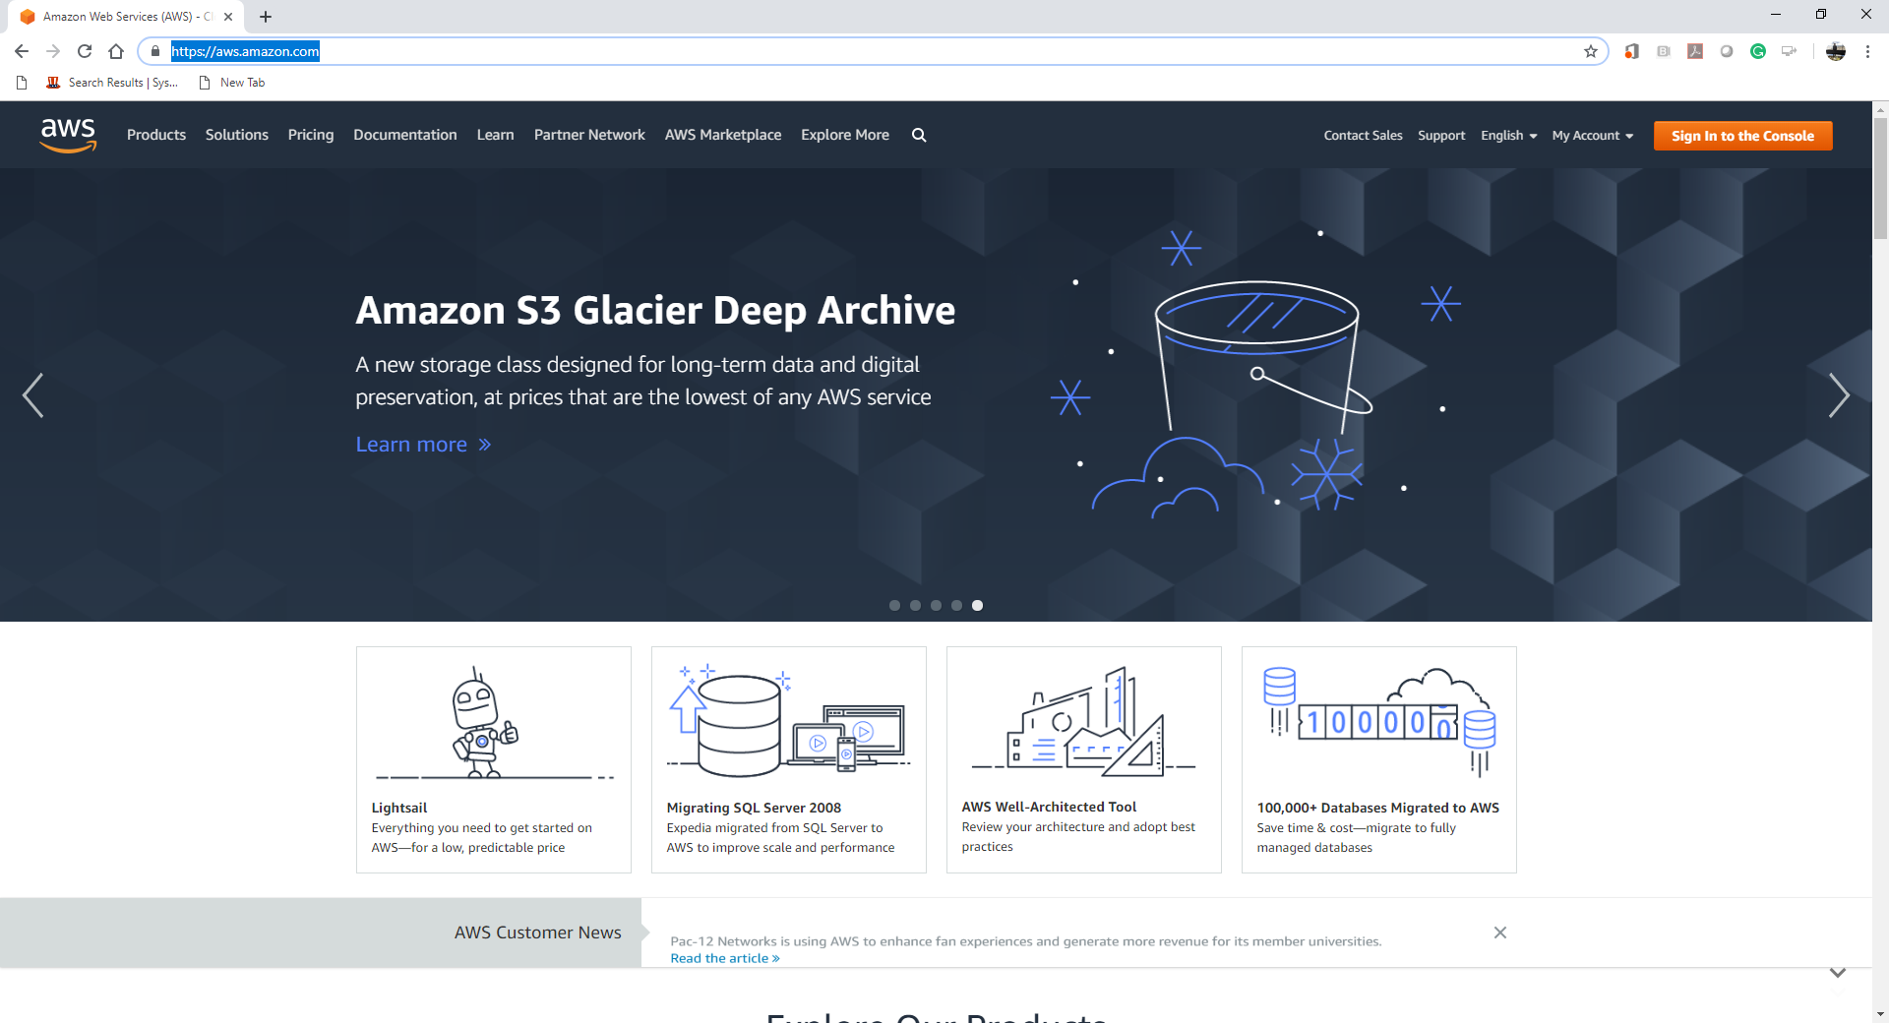

1. In the AWS Management Console, type “IAM” in the *Find services*search bar and   
   click IAM when the search result shows up.

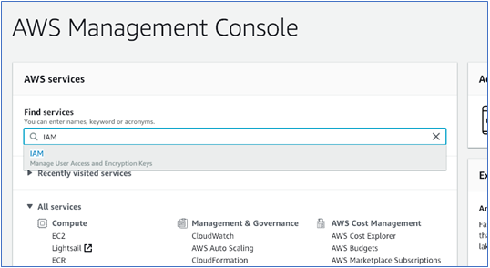

1. In the IAM interface, click “Users” button in the left-pane menu   
   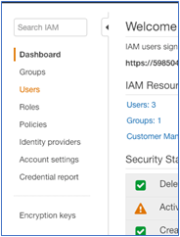
2. Click “Add user” button.
3. Fill out the User name (i.e. johndoe or janedoe) and select Access type as “Programmatic access” and click “Next Permissions” button. In this case, we used “TestUser” for a user name.

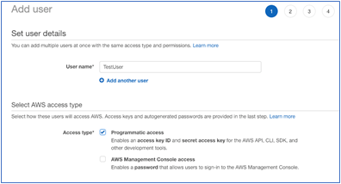

1. Click “Create group” button to add a new group.   
   A group name should be given and the “AdministratorAccess” policy should be selected.   
   We used “TestGroup” for a group name.  
   (Our setup is not the best practice. This is just for the purpose of demonstrating.   
   In real use cases, the administrator access is not assigned to all people.)   
   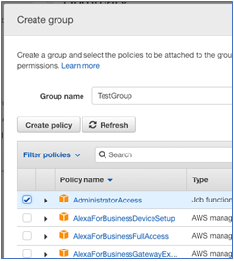

1. Create the “Create group” button to return the previous page and   
   check the new group you just added.
2. Click the “Next: Tags” button.

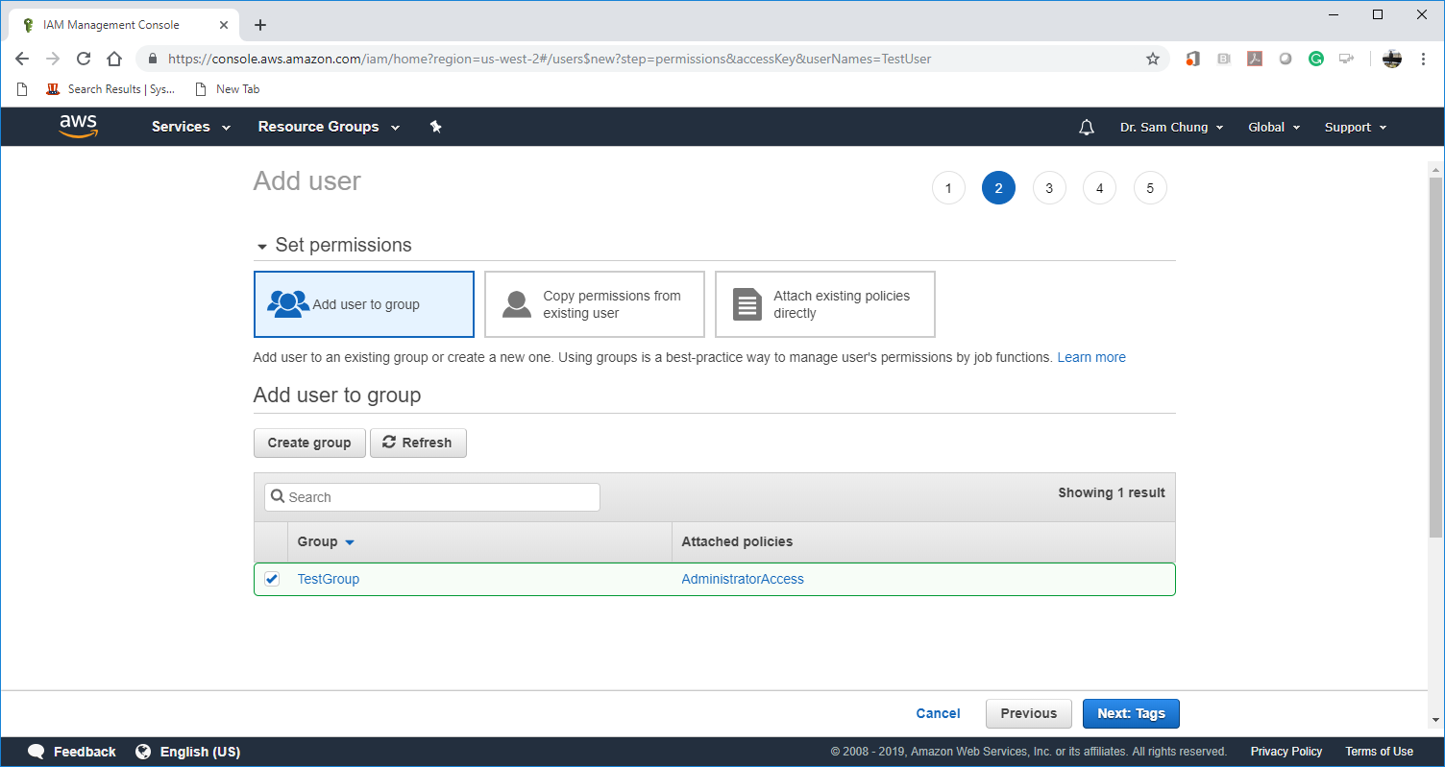

1. Click the “Next: Review: button.

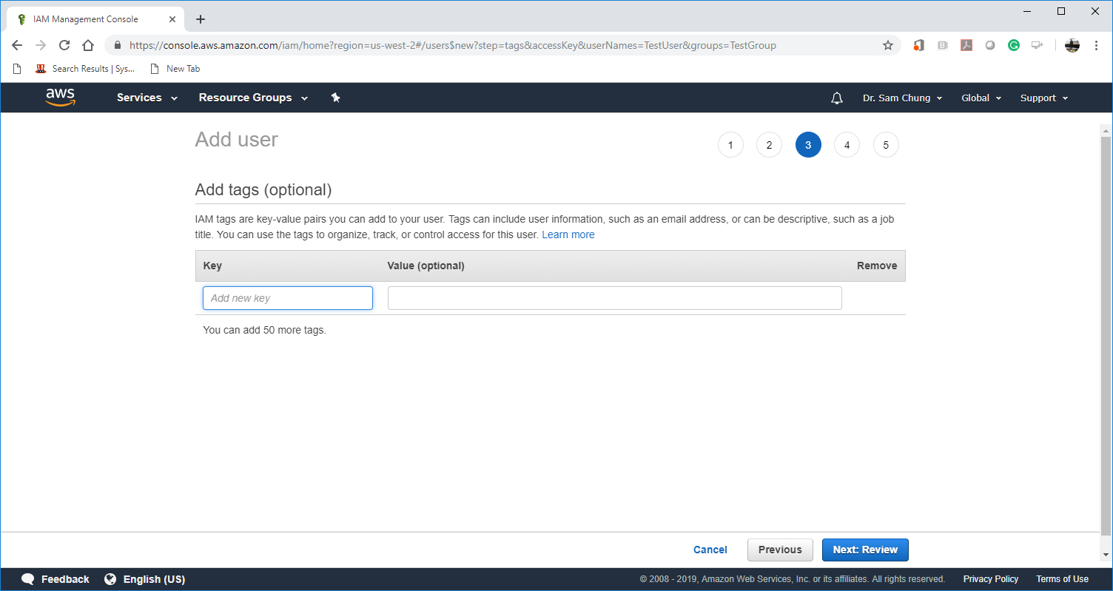

1. Click the “Create user” button.

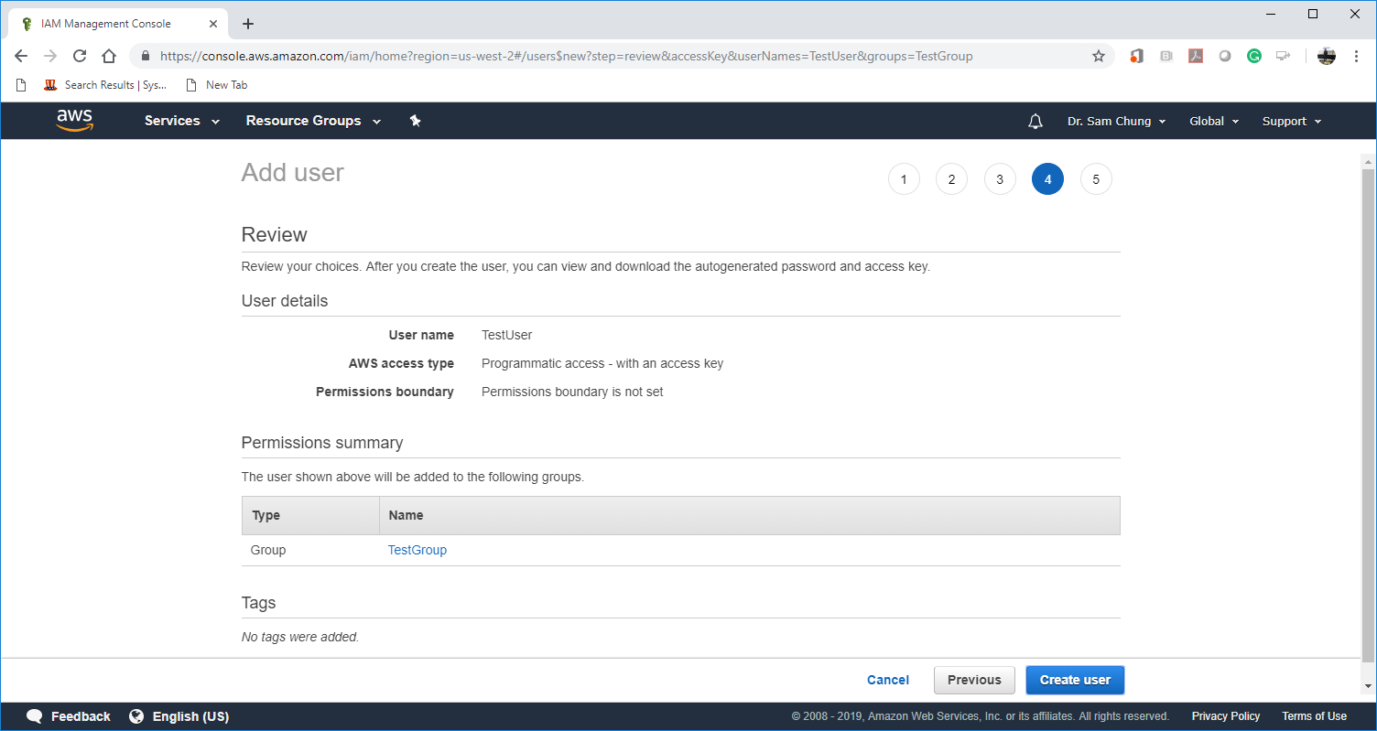

1. You should see the success information and the information of the new user.

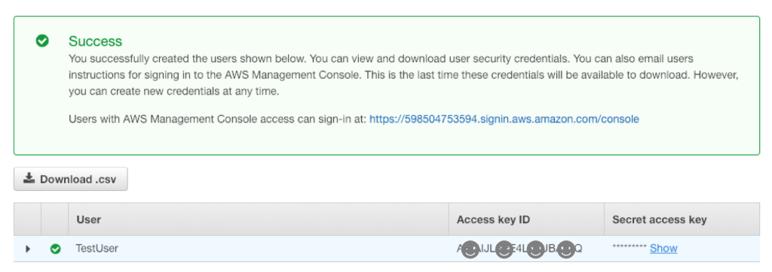

1. Click the “Show” button to see the Secret access key.   
   We will use them for this course later.
2. Click “Download.csv” and keep the file somewhere safe. Note:
   * **You only know the place to keep both the Access key ID and Secret access key.**
   * If you lose these keys, you are not able to come back to get them again.   
     You have to regenerate the keys.
   * These keys are very important because they grant access to all your AWS services.   
     Please keep them safely.

